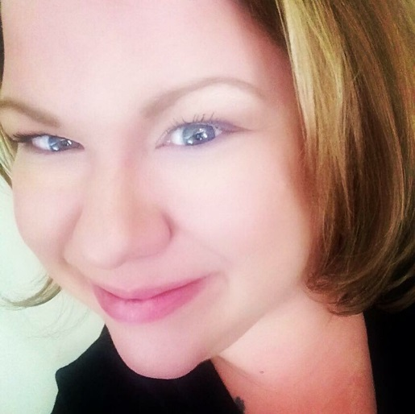 |  | Dear Valued Parents and Guardians,  Welcome back to the 2018-2019 school year! I will be your child’s Special Education service provider for the General Education Co-Taught classes. I am so excited to work with all of you this year!  Prior to this school year I was in the middle school and am now teaching intermediate. I will be planning and co-teaching your child’s ELA and Math classes, My office is located in Room 213. I have an art therapy center, yoga mats and a small instructional area set up so those who need to test separate and or need to take a break can do so. I look forward to working as a team to make sure your child has a successful and fun school year! I can be reached at the information to your left.  When I am not at Stone I am a working artist in Chicago and have work in galleries in Arizona, New York and New Orleans. I love to incorporate hands on learning opportunities that integrate art into the general education curriculum. I also run an after school art studio that will be starting very soon. I am married and have three rescue dogs. For hobbies I love to cook, write curriculum, and collect vintage cookbooks and hike in the desert!  Please feel free to reach out and you are more than welcome to visit at any time! I have a Google Classroom that I post weekly updates on so please- when you get a minute- could you email me your best contact information and an email address so I can invite you to the classroom?  See you all soon!  Sincerely,  Paula Baldocchi  Diverse Learners Teacher , Stone Scholastic Academy  MsSPED, MFA,LBS1 and Type 09

Mrs. Baldocchi
Diverse Learners Teacher Grades 3-5

CONTACT
PHONE:
1(773) 534-2045

Fax:
1(773) 534-2092

Website:
https://mrsbaldocchi.weebly.com/

EMAIL:
Pkbaldocchi@cps.edu

